CPE301 – SPRING 2019

Design Assignment 5

Student Name: Rocky Yasuaki Gonzalez

Student #: 5003229733

Student Email: gonzar14@unlv.nevada.edu

Primary Github address: https://github.com/rockyg1995/ihswppdar.git

Directory: C:\Users\rocky\Documents\CpE 301+L - Embedded Systems Design\CpE

301\Repository\DesignAssignments\DA5

Submit the following for all Labs:

1. In the document, for each task submit the modified or included code (only) with highlights and justifications of the modifications. Also, include the comments.
2. Use the previously create a Github repository with a random name (no CPE/301, Lastname, Firstname). Place all labs under the root folder ESD301/DA, sub-folder named LABXX, with one document and one video link file for each lab, place modified asm/c files named as LabXX-TYY.asm/c.
3. If multiple asm/c files or other libraries are used, create a folder LabXX-TYY and place these files inside the folder.
4. The folder should have a) Word document (see template), b) source code file(s) and other include files, c) text file with youtube video links (see template).

1. **COMPONENTS LIST AND FLOW DIAGRAMS**

Atmega328PB Xplained Mini

Micro USB Cable (Power Supply)

Breadboard

LM35

RF24L01

Male/Female Wires

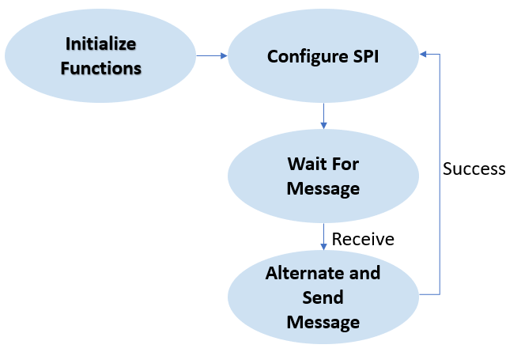

*Figure 1 – Flow Chart for Coding Algorithm in Task*

1. **INITIAL/DEVELOPED CODE OF TASK**

/*

* DA5.c

*

* Created: 4/27/2019 7:16:05 AM

* Author: RYG95

*/

#ifndef *F_CPU*

#define *F_CPU* 16000000UL

#endif

#include <avr/io.h>

#include <util/delay.h>

#include <avr/interrupt.h>

#include <stdbool.h>

#include <stdio.h>

#include <string.h>

// Set up UART for printf();

#ifndef BAUD

#define BAUD 9600

#endif

#include "STDIO_UART.h"

// Include nRF24L01+ library

#include "nrf24l01.h"

#include "nrf24l01-mnemonics.h"

#include "spi.h"

void print_config(void);

void adc_init(void); // Initialize Analog to Digital Converter

void read_adc(void); // Read temperature received from ADC

void USART_send(unsigned char data); // Send individual char data into UDR0

void USART_putstring(char* StringPtr); // Break string into individual chars and send

volatile float adc_temp; // Stores ADC Value representing Temperature

char outs[20]; // 'outs[]' used to store integer and float

// Used in IRQ ISR

volatile bool message_received = false;

volatile bool status = false;

int main(void) {

// Set cliche message to send (message cannot exceed 32 characters)

char tx_message[32]; // Define string array

*strcpy*(tx_message,"Hello World!"); // Copy string into array

// Initialize UART

uart_init();

adc_init();

float adc_tempf;

// Initialize nRF24L01+ and print configuration info

nrf24_init();

print_config();

// Start listening to incoming messages

nrf24_start_listening();

status = nrf24_send_message(tx_message);

if (status == true) {

*printf*("Message sent successfully\n")

read_adc();

adc_tempf = (ADCH << 8) + ADCL; // 'T(C) = Vout/10mV', 'TOS = ADC - T(C)'

adc_tempf = (9/5)*adc_tempf + 32; // Converts Celsius to Fahrenheit

*snprintf*(outs,sizeof(outs),"%3f\r\n", adc_tempf); // Store integer->string

USART_putstring(outs);

}

while (1) {

status = nrf24_send_message(tx_message);

if (message_received) {

// Message received, print it

message_received = false;

*printf*("Received message from geo: %s\n",nrf24_read_message());

// Send message as response

*_delay_ms*(500);

if (status == true) *printf*("Message sent successfully\n");

}

}

}

// Interrupt on IRQ pin

ISR(INT0_vect) {

message_received = true;

}

void print_config(void) {

*uint8_t* data;

*printf*("Startup successful\n\n nRF24L01+ configured as:\n");

*printf*("-------------------------------------------\n");

nrf24_read(CONFIG,&data,1);

*printf*("CONFIG 0x%x\n",data);

nrf24_read(EN_AA,&data,1);

*printf*("EN_AA 0x%x\n",data);

nrf24_read(EN_RXADDR,&data,1);

*printf*("EN_RXADDR 0x%x\n",data);

nrf24_read(SETUP_RETR,&data,1);

*printf*("SETUP_RETR 0x%x\n",data);

nrf24_read(RF_CH,&data,1);

*printf*("RF_CH 0x%x\n",data);

nrf24_read(RF_SETUP,&data,1);

*printf*("RF_SETUP 0x%x\n",data);

nrf24_read(STATUS,&data,1);

*printf*("STATUS 0x%x\n",data);

nrf24_read(FEATURE,&data,1);

*printf*("FEATURE 0x%x\n",data);

*printf*("-------------------------------------------\n\n");

}

void adc_init(void) {

ADMUX = (0<<REFS1)|(1<<REFS0)| // Reference Select Bits, AVcc Ext cap at AREF

(0<<ADLAR)| // ADC Left Adjust Result

(0<<MUX3)|(1<<MUX2)|(0<<MUX1)|(1<<MUX0); // Analog Channel 'ADC5' (PC5)

ADCSRA = (1<<ADEN)| // ADC Enable

(0<<ADSC)| // ADC Start Conversion

(0<<ADATE)| // ADC Auto Trigger Enable

(0<<ADIF)| // ADC Interrupt Flag

(0<<ADIE)| // ADC Interrupt Enable

(1<<ADPS2)|(0<<ADPS1)|(1<<ADPS0); // ADC Prescaler Select Bits '32'

}

void read_adc(void) {

unsigned char i = 4; // Set 'i' for iterations

adc_temp = 0; // set float 'adc_temp'

while (i--) { // Decrement 'i' until 4 samples take

ADCSRA |= (1<<ADSC); // If ADSC high (ADC Start Conversion)...

while (ADCSRA & (1<<ADSC)); // Start ADC Conversion

adc_temp += ADC; // Store analog value of current adc_temp

*_delay_ms*(50); // delay 50ms for sampling

}

adc_temp = (adc_temp/4); // Average of 4 samples into adc_temp

}

void USART_send(unsigned char data) { // Transmit ASCII value into UDR0

while (!(UCSR0A & (1 << UDRE0))); // Check UDRE0 'High' to break loop

UDR0 = data; // Unsigned char serial data into UDR0

}

void USART_putstring(char* StringPtr) { // Break string->chars, then USART_send()

while (*StringPtr != 0x00) { // Keep Looping until String Completed

USART_send(*StringPtr); // Send char pointed by string pointer

StringPtr++; // Increment pointer next char location

}

}

1. **SCHEMATICS**

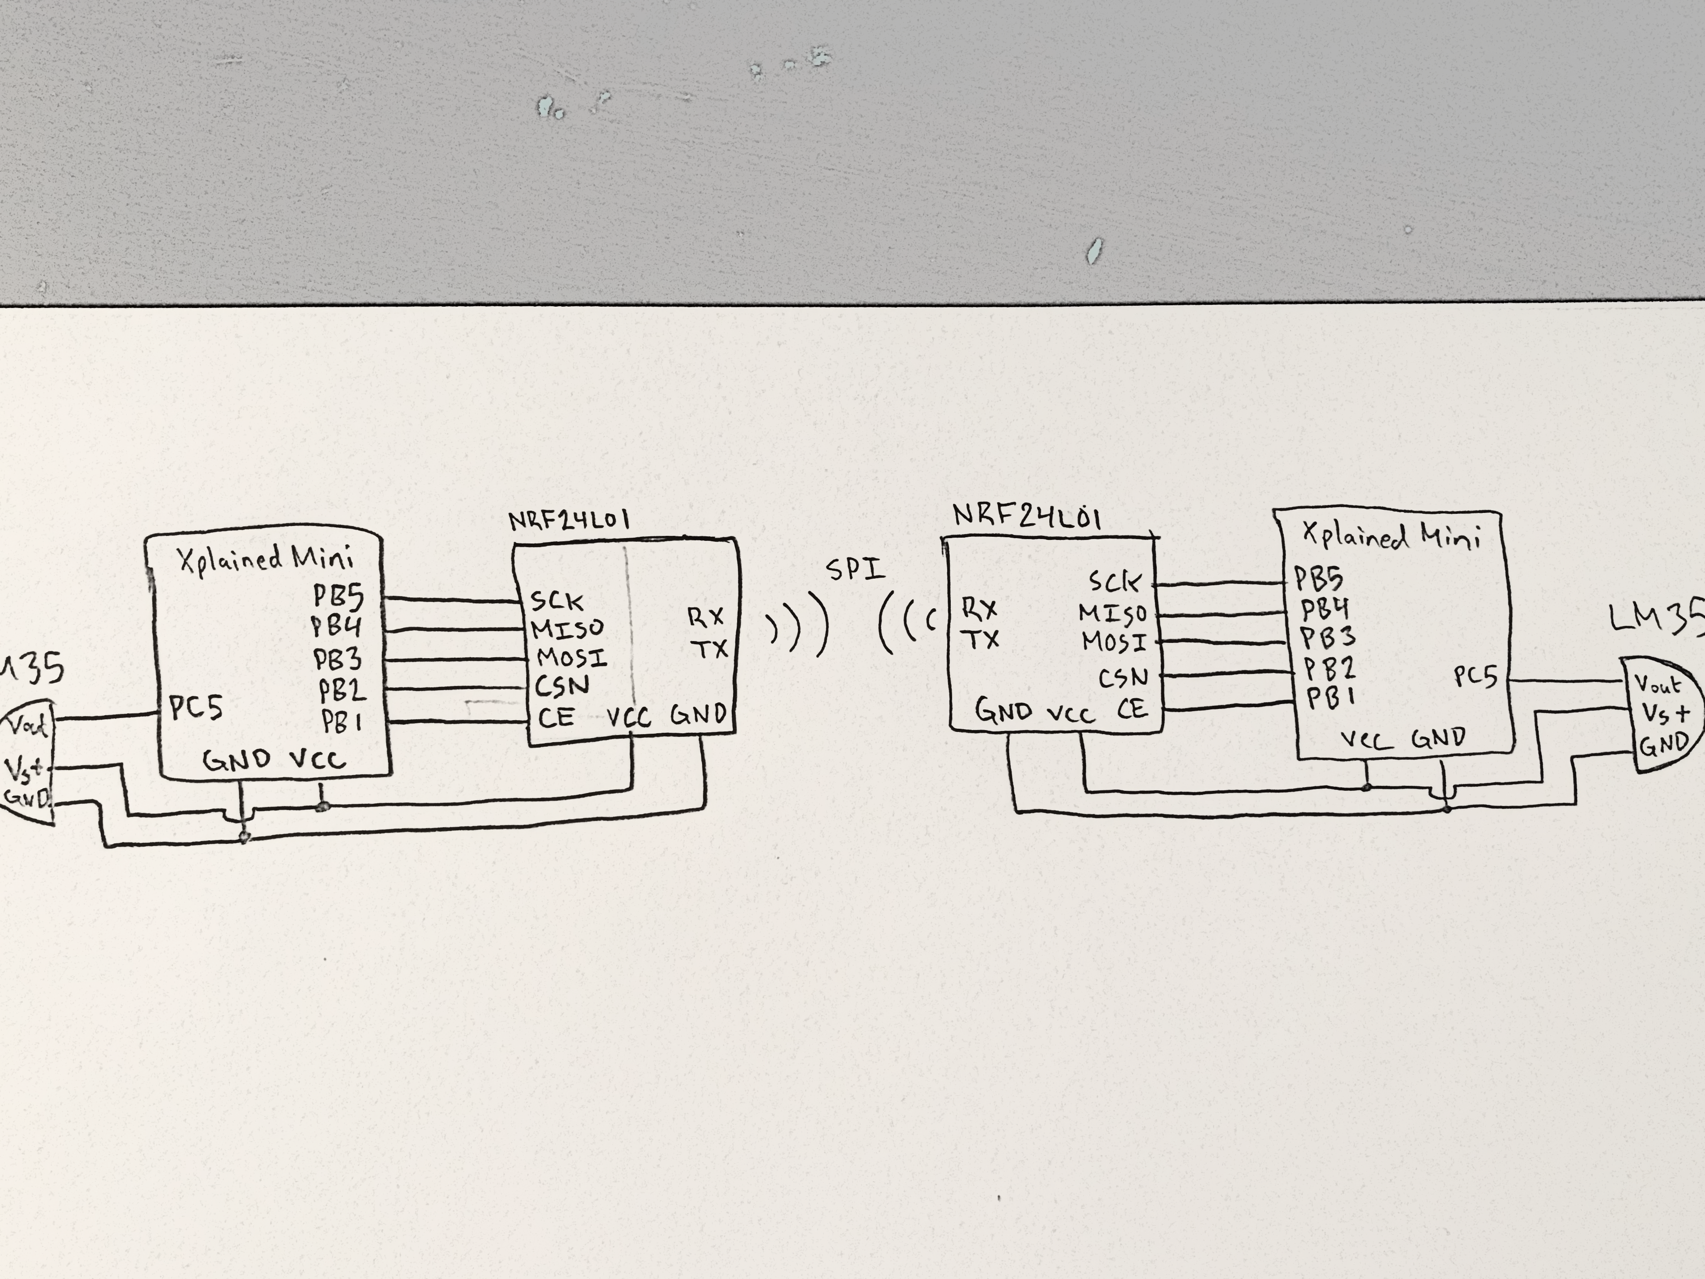

*Figure 2 – Schematic of two Atmega328P/PB Xplained Minis + SPI Modules*

1. **SCREENSHOTS OF EACH TASK OUTPUT (ATMEL STUDIO OUTPUT)**

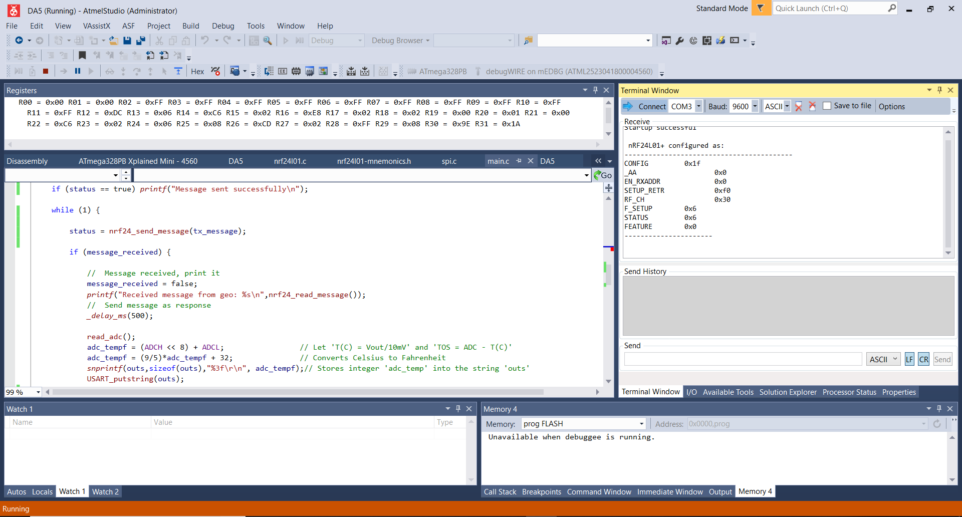

*Figure 3 – Output Terminal for Configuration of SPI Module*

There were problems communicating both devices to each after setting data to correct proper channels and opposite pipe addresses. We conclude that the assignment may have problems connecting Atmega328PB models since we’ve spoke to other classmates who’ve not had problems however had used the Atmega328P models.

1. **SCREENSHOT OF EACH DEMO (BOARD SETUP)**

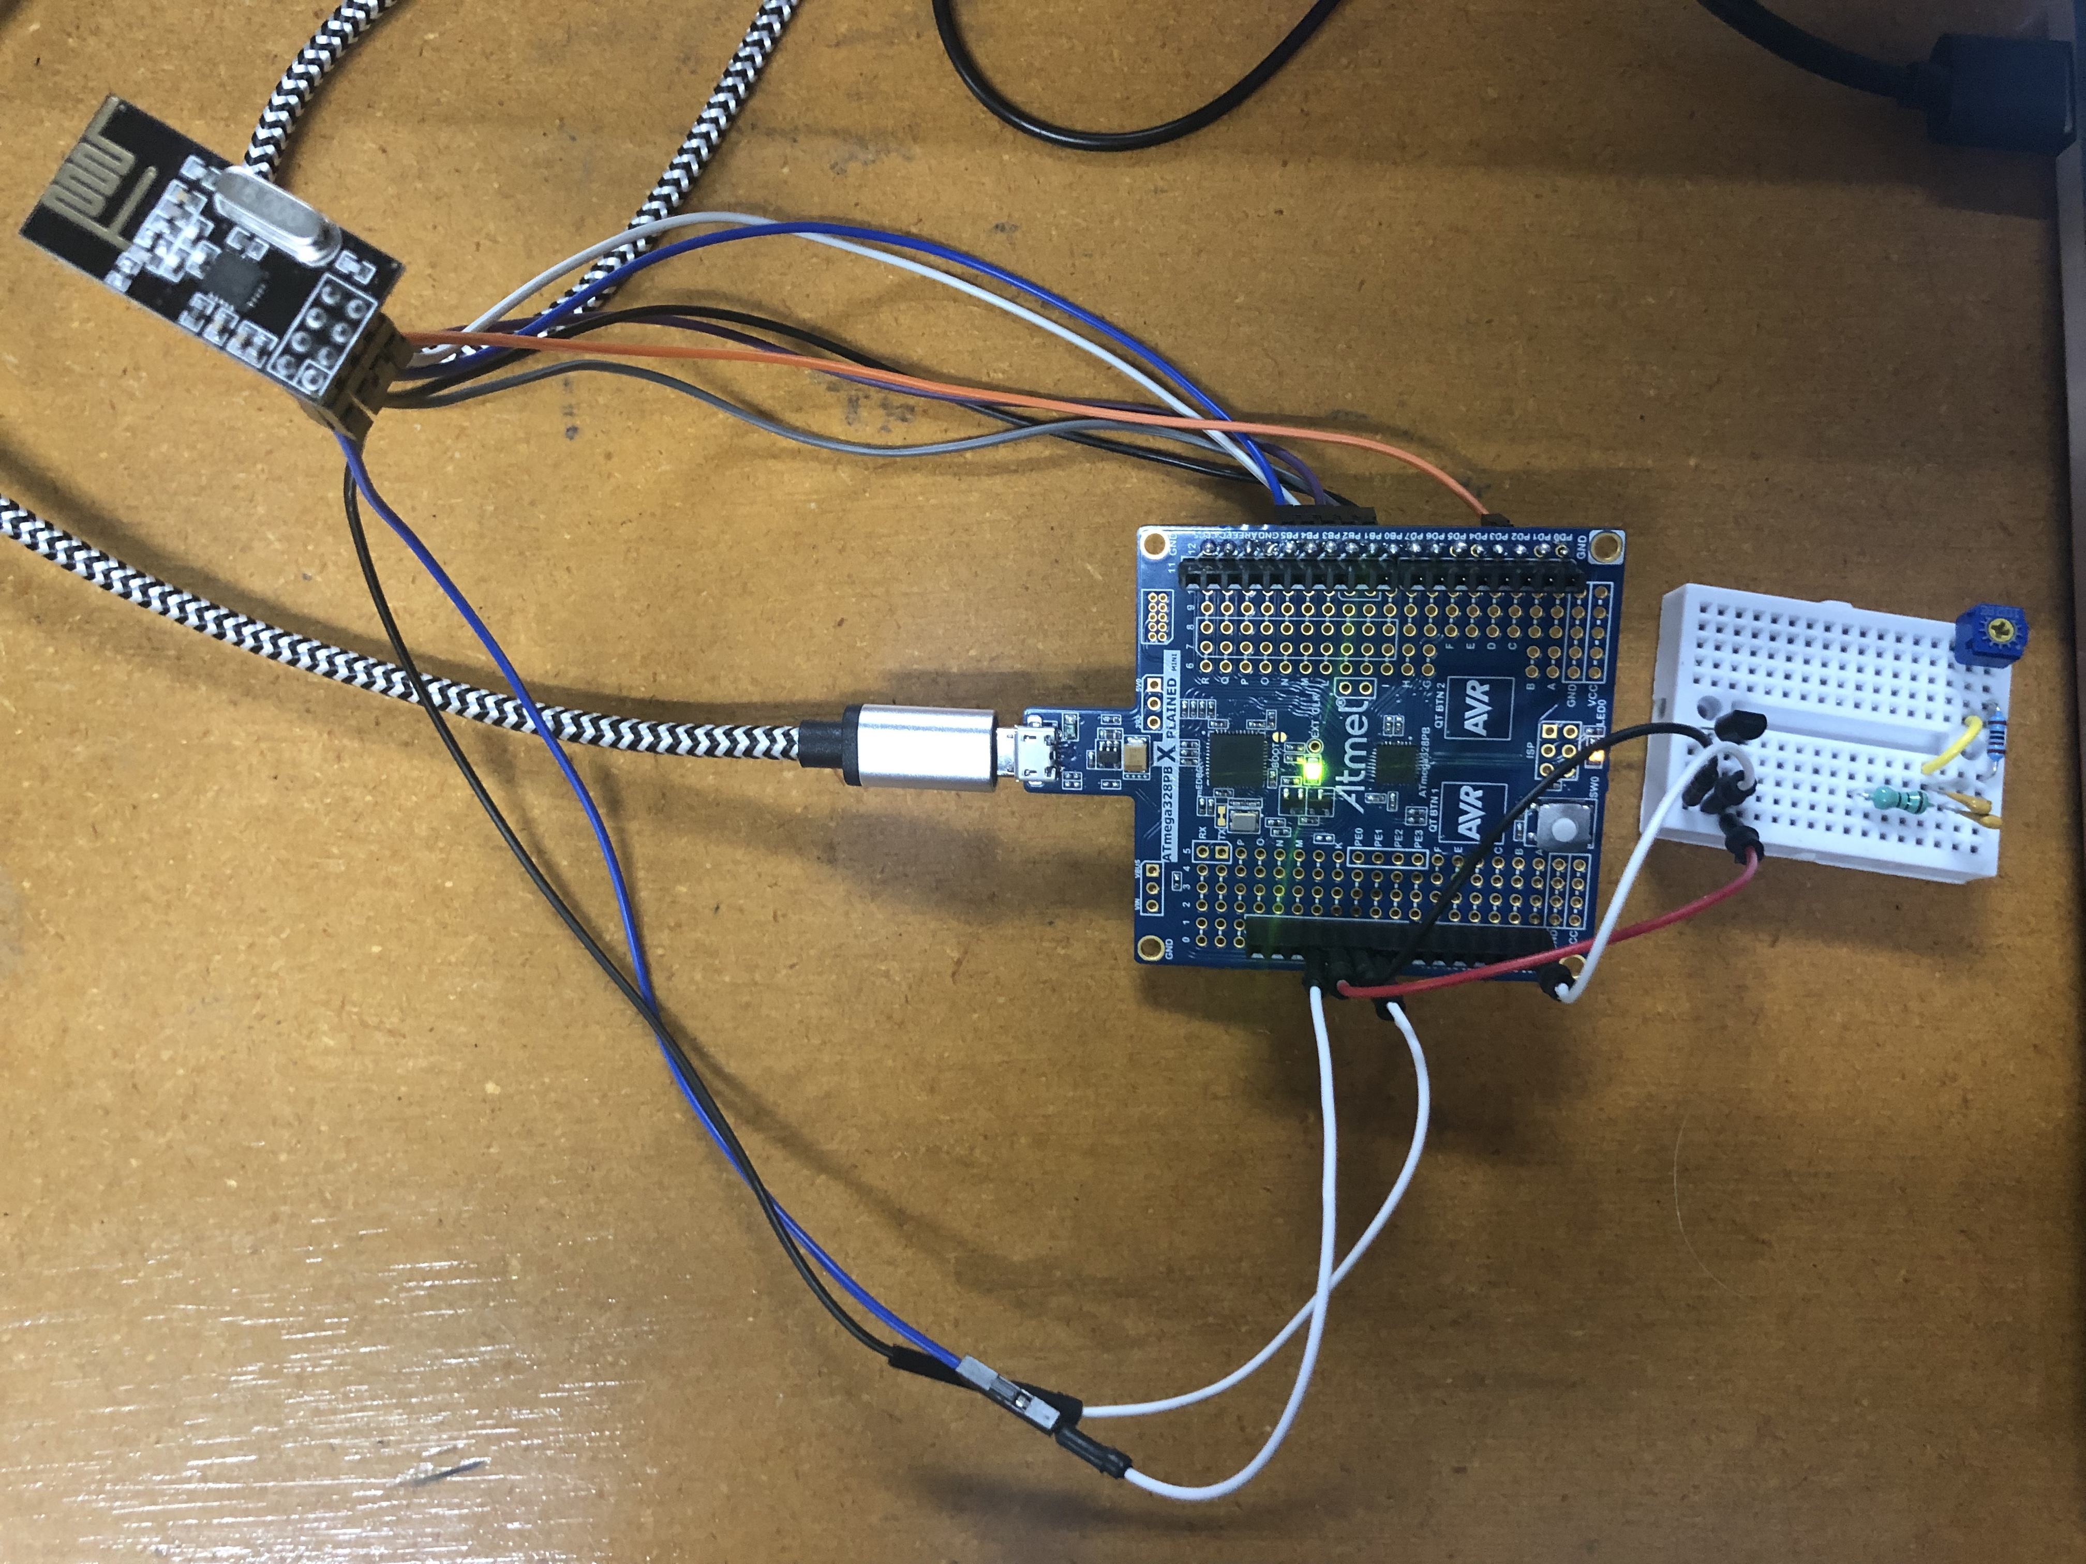

*Figure 4 – Connecting NRF24L01 to the Xplained Mini + LM35 Temperature Sensor*

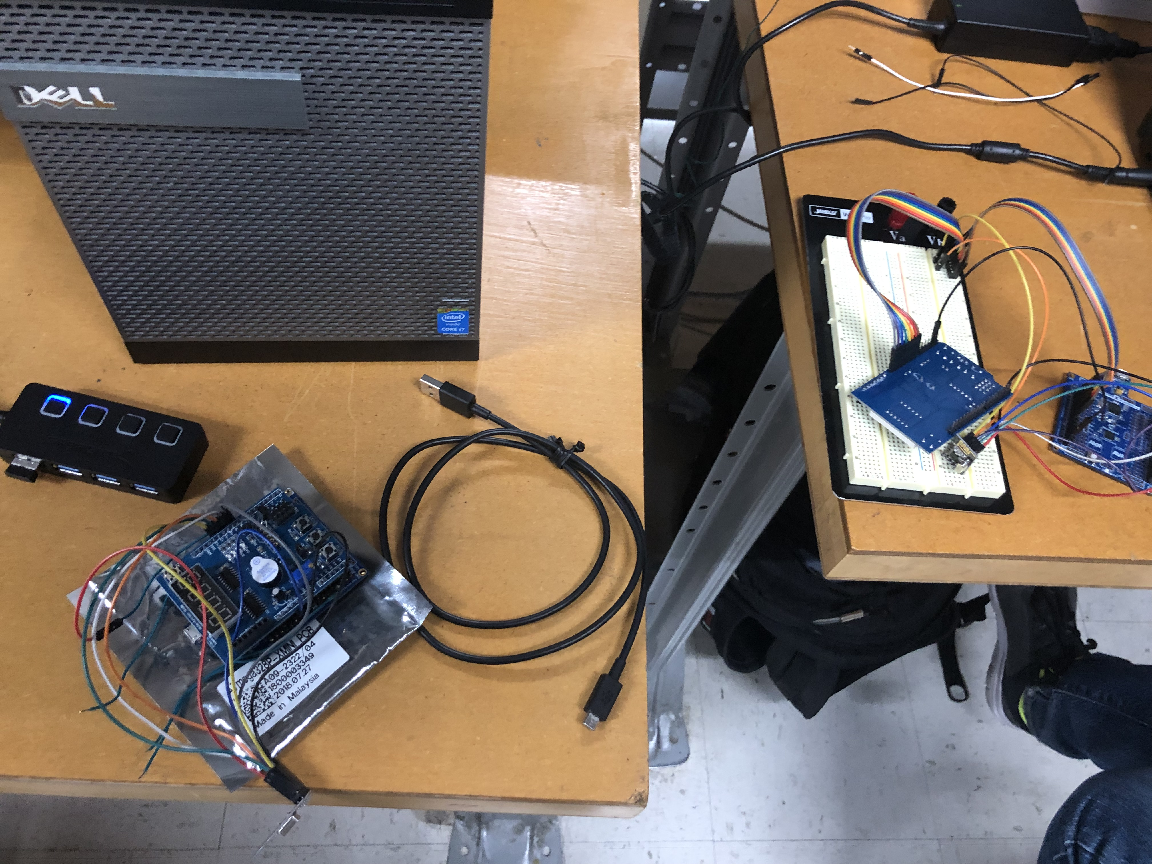

*Figure 5 – Connecting two Xplained Minis/NRF24L01 Modules*

1. **VIDEO LINKS OF EACH DEMO**

N/A

1. **GITHUB LINK OF THIS DA**

https://github.com/rockyg1995/ihswppdar/tree/master/DesignAssignments/DA5

**Student Academic Misconduct Policy**

<http://studentconduct.unlv.edu/misconduct/policy.html>

“This assignment submission is my own, original work”.

Rocky Gonzalez